43.73: a) 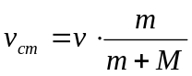
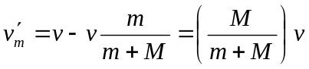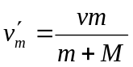
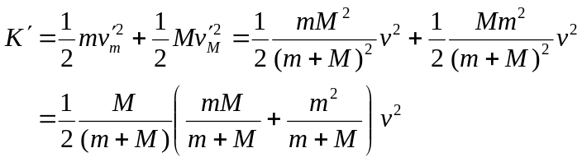
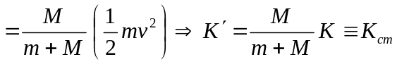
b) For an endoenergetic reaction 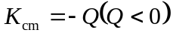 at threshold. Putting this into part
(a) gives 